# Tutorial

<https://blogs.sap.com/2020/12/27/automated-testing-with-ui5/>

# Install Tescafe installation

npm i ui5-testcafe-selector-utils

npm i typescript

npm i testcafe

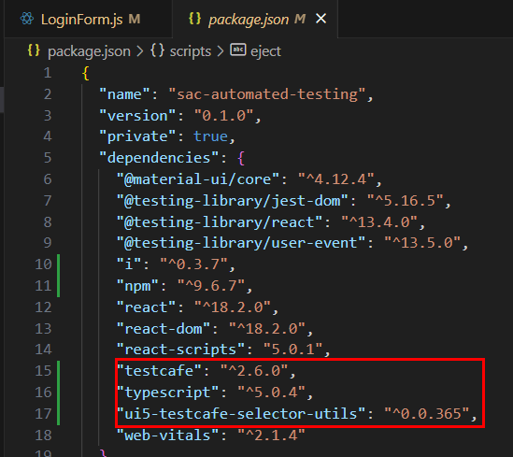

# ESLINT

<https://testcafe.io/documentation/402831/guides/basic-guides/test-structure#fixtures>

npm i eslint-plugin-testcafe

# Test Files

Create testfiles on server for users.

** - go through all folders

*.e2e.js – use only files which have e2e at the end



# IDs

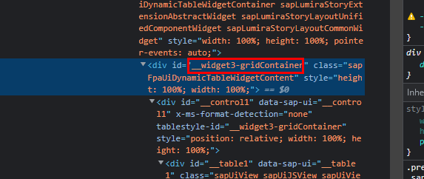

## Selectors Doku

<https://github.com/timostark/ui5-testcafe-selector-utils/blob/main/doc/selectors.md>

Hilfreich:

* Wenn man mehrere Klassen hat, dann keine leerzeichem im Code
  + 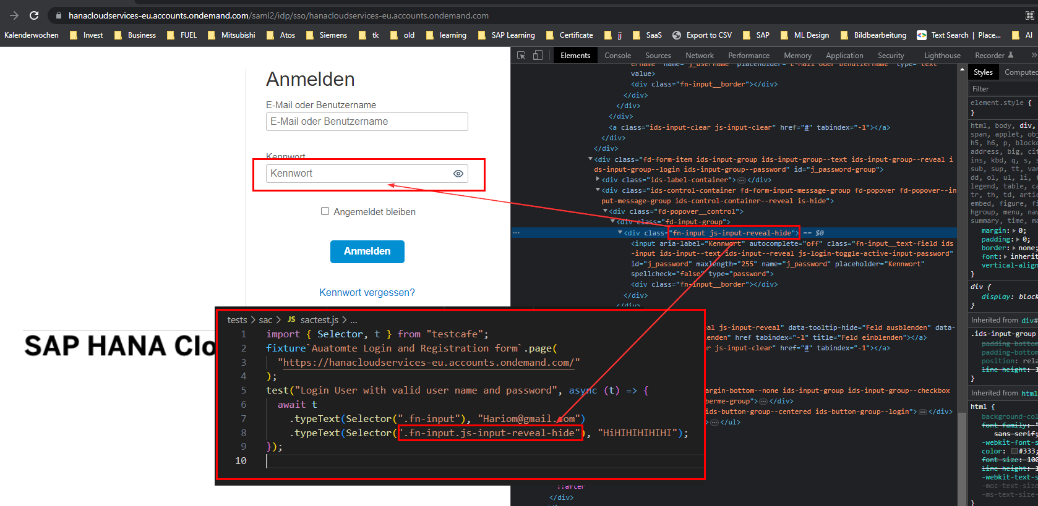

Test Cafe Live

<https://www.youtube.com/watch?v=RWQtB6Xv01Q>

Some nice searc setting and live mode: <https://www.youtube.com/watch?v=qpRyAl4hSg0>



2 concurent browsers



Docker testcafe

<https://www.youtube.com/watch?v=9S0p3RtM4bE>